To use these rules for custom content, simply copy and paste this attribution:

This work, “YOUR WORK TITLE”, is adapted from “SimpleTop” by [Dylan Fair](https://www.dfair.me/), used under [CC BY 4.0](https://creativecommons.org/licenses/by/4.0/).

Here are some helpful links for providing attribution to other sources you might want to use, or even for determining your own licensing:

<https://creativecommons.org/>

<https://wiki.creativecommons.org/wiki/Recommended_practices_for_attribution#Examples_of_attribution>

And finally, here are my attributions for work that I utilize:

Draw-4067546_1280 by [GDJ](https://pixabay.com/users/gdj-1086657/) is licensed under [Pixabay’s Content License](https://pixabay.com/service/license-summary/)



Battery pack empty icon by [sbed](http://opengameart.org/content/95-game-icons) under [CC BY 3.0](http://creativecommons.org/licenses/by/3.0/)



Strong icon by [Lorc](https://lorcblog.blogspot.com) under [CC BY 3.0](http://creativecommons.org/licenses/by/3.0/)



Juggler icon by [Lorc](https://lorcblog.blogspot.com) under [CC BY 3.0](http://creativecommons.org/licenses/by/3.0/)



Shield icon by [sbed](http://opengameart.org/content/95-game-icons) under [CC BY 3.0](http://creativecommons.org/licenses/by/3.0/)

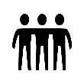

Three friends icon by [Delapouite](https://delapouite.com) under [CC BY 3.0](http://creativecommons.org/licenses/by/3.0/)

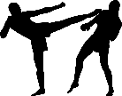kickboxing-3635864_1280 by [Mohamed Hassan](https://pixabay.com/users/mohamed_hassan-5229782/?utm_source=link-attribution&utm_medium=referral&utm_campaign=image&utm_content=3635864) from [Pixabay](https://pixabay.com/?utm_source=link-attribution&utm_medium=referral&utm_campaign=image&utm_content=3635864)

clapperboard-29986_1280 by [Clker-Free-Vector-Images](https://pixabay.com/users/clker-free-vector-images-3736/?utm_source=link-attribution&utm_medium=referral&utm_campaign=image&utm_content=29986) from [Pixabay](https://pixabay.com/?utm_source=link-attribution&utm_medium=referral&utm_campaign=image&utm_content=29986)

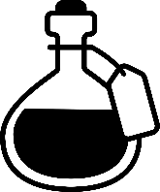

brew-2672319_1280 by [Ricarda Mölck](https://pixabay.com/users/ricinator-3282802/?utm_source=link-attribution&utm_medium=referral&utm_campaign=image&utm_content=2672319) from [Pixabay](https://pixabay.com/?utm_source=link-attribution&utm_medium=referral&utm_campaign=image&utm_content=2672319)

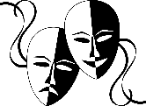

masks-40963_1280 by [Clker-Free-Vector-Images](https://pixabay.com/users/clker-free-vector-images-3736/?utm_source=link-attribution&utm_medium=referral&utm_campaign=image&utm_content=40963) from [Pixabay](https://pixabay.com/?utm_source=link-attribution&utm_medium=referral&utm_campaign=image&utm_content=40963)



silhouette-3129148_1280 by [Mohamed Hassan](https://pixabay.com/users/mohamed_hassan-5229782/?utm_source=link-attribution&utm_medium=referral&utm_campaign=image&utm_content=3129148) from [Pixabay](https://pixabay.com/?utm_source=link-attribution&utm_medium=referral&utm_campaign=image&utm_content=3129148)

group-1962592_1280 by [Ricarda Mölck](https://pixabay.com/users/ricinator-3282802/?utm_source=link-attribution&utm_medium=referral&utm_campaign=image&utm_content=1962592) from [Pixabay](https://pixabay.com/?utm_source=link-attribution&utm_medium=referral&utm_campaign=image&utm_content=1962592)

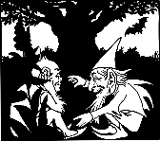Afbeelding by [Gordon Johnson](https://pixabay.com/nl/users/gdj-1086657/?utm_source=link-attribution&utm_medium=referral&utm_campaign=image&utm_content=4575930) from [Pixabay](https://pixabay.com/?utm_source=link-attribution&utm_medium=referral&utm_campaign=image&utm_content=1962592)

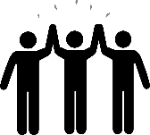

Stick people by [kdbcms](https://pixabay.com/users/kdbcms-578901/?utm_source=link-attribution&utm_medium=referral&utm_campaign=image&utm_content=2324013) from [Pixabay](https://pixabay.com/?utm_source=link-attribution&utm_medium=referral&utm_campaign=image&utm_content=1962592)

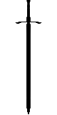sword by [OpenClipart-Vectors](https://pixabay.com/users/openclipart-vectors-30363/?utm_source=link-attribution&utm_medium=referral&utm_campaign=image&utm_content=161331) from [Pixabay](https://pixabay.com/?utm_source=link-attribution&utm_medium=referral&utm_campaign=image&utm_content=1962592)

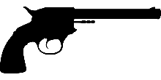gun by [OpenClipart-Vectors](https://pixabay.com/users/openclipart-vectors-30363/?utm_source=link-attribution&utm_medium=referral&utm_campaign=image&utm_content=161331) from [Pixabay](https://pixabay.com/?utm_source=link-attribution&utm_medium=referral&utm_campaign=image&utm_content=1962592)

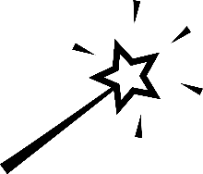

wand by [OpenClipart-Vectors](https://pixabay.com/users/openclipart-vectors-30363/?utm_source=link-attribution&utm_medium=referral&utm_campaign=image&utm_content=161331) from [Pixabay](https://pixabay.com/?utm_source=link-attribution&utm_medium=referral&utm_campaign=image&utm_content=1962592)

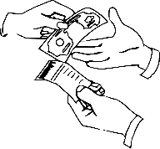money by [Clker-Free-Vector-Images](https://pixabay.com/users/clker-free-vector-images-3736/?utm_source=link-attribution&utm_medium=referral&utm_campaign=image&utm_content=38268) from [Pixabay](https://pixabay.com/?utm_source=link-attribution&utm_medium=referral&utm_campaign=image&utm_content=38268)

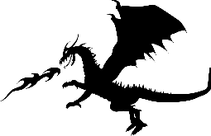

dragon by [Mohamed Hassan](https://pixabay.com/users/mohamed_hassan-5229782/?utm_source=link-attribution&utm_medium=referral&utm_campaign=image&utm_content=3975574) from [Pixabay](https://pixabay.com/?utm_source=link-attribution&utm_medium=referral&utm_campaign=image&utm_content=3975574)



Character icon by [Delapouite](https://delapouite.com) under [CC BY 3.0](http://creativecommons.org/licenses/by/3.0/)

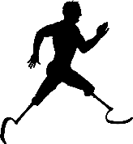Pralympics Image by [Gordon Johnson](https://pixabay.com/users/gdj-1086657/?utm_source=link-attribution&utm_medium=referral&utm_campaign=image&utm_content=4925754) from [Pixabay](https://pixabay.com/?utm_source=link-attribution&utm_medium=referral&utm_campaign=image&utm_content=4925754)

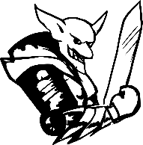

Fantasy Image by [OpenClipart-Vectors](https://pixabay.com/users/openclipart-vectors-30363/?utm_source=link-attribution&utm_medium=referral&utm_campaign=image&utm_content=1296495) from [Pixabay](https://pixabay.com/?utm_source=link-attribution&utm_medium=referral&utm_campaign=image&utm_content=1296495)

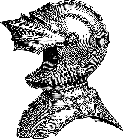helmet Image by [Gordon Johnson](https://pixabay.com/users/gdj-1086657/?utm_source=link-attribution&utm_medium=referral&utm_campaign=image&utm_content=7258914) from [Pixabay](https://pixabay.com/?utm_source=link-attribution&utm_medium=referral&utm_campaign=image&utm_content=7258914)

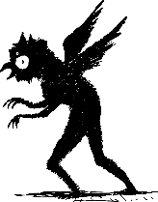bird Image by [Colleen](https://pixabay.com/users/stargladevintage-17411787/?utm_source=link-attribution&utm_medium=referral&utm_campaign=image&utm_content=5596266) from [Pixabay](https://pixabay.com/?utm_source=link-attribution&utm_medium=referral&utm_campaign=image&utm_content=5596266)

Treasure map icon by [Lorc](https://lorcblog.blogspot.com) under [CC BY 3.0](http://creativecommons.org/licenses/by/3.0/)

Swap bag icon by [Lorc](https://lorcblog.blogspot.com) under [CC BY 3.0](http://creativecommons.org/licenses/by/3.0/)

Image by [Gordon Johnson](https://pixabay.com/users/gdj-1086657/?utm_source=link-attribution&utm_medium=referral&utm_campaign=image&utm_content=2773445) from [Pixabay](https://pixabay.com/?utm_source=link-attribution&utm_medium=referral&utm_campaign=image&utm_content=2773445)

Image by [Gordon Johnson](https://pixabay.com/users/gdj-1086657/?utm_source=link-attribution&utm_medium=referral&utm_campaign=image&utm_content=2773445) from [Pixabay](https://pixabay.com/?utm_source=link-attribution&utm_medium=referral&utm_campaign=image&utm_content=2773445)

Sample Map provided by <https://2minutetabletop.com/>